Exact Concept-Grouped SHAP Explanations of a Deployed Real-Time PM2.5 Ensemble for Texas Census Tracts
Saketh Chebrolu  St. Mark's School of Texas  Dallas, TX, USA  chebrolusaketh@gmail.com | Nathan Tan  St. Mark's School of Texas  Dallas, TX, USA  nathantan2027@gmail.com | Yifeng Wang  School of Civil and Environmental Engineering  Georgia Institute of Technology  Atlanta, GA, USA  ywang3627@gatech.edu

Abstract—Low-cost sensor networks feed operational air quality maps, but the models behind them are rarely explained to the communities relying on them. This paper presents an exact explanation layer for a deployed platform that maps PM2.5 across 6,896 Texas census tracts, validated at 0.71 by leave-one-sensor-out testing. Blending per-model TreeExplainer attributions with deployment weights reconstructs every prediction exactly; sums over five concept groups make predictions readable in physical units. The explanations reveal a spatial nowcaster: neighbor features dominate, carry a smoke event nearly alone, and suppress hyper-local events no neighbor observes, motivating targeted sensor placement and policy guardrails.
Index Terms—explainable artificial intelligence, SHAP, air quality, PM2.5, low-cost sensors, ensemble learning, environmental monitoring
I. Introduction
Low-cost optical sensors have changed who gets to see air pollution. Networks such as PurpleAir now report fine particulate matter (PM2.5) at neighborhood scale and minute cadence, and corrected versions of their data feed public tools such as the AirNow Fire and Smoke Map [1]. The placement of these sensors is itself uneven across income groups [2], so the models that interpolate between them are, for many communities, the only air quality information available.
Such tools are judged almost entirely on accuracy. A fused ensemble over sensor, satellite, meteorological, and demographic inputs can validate well yet behave in ways its operators would not expect, and when its outputs color a public map or steer monitor placement, unexamined behavior is a liability. Shapley additive explanation (SHAP) methods [3], [4] have made attribution practical for tree models, and environmental applications such as flood-susceptibility mapping have begun to adopt them [5]. Yet the explanations almost always describe research models; deployed systems, the ones people actually consult, remain largely unexplained.
This paper explains one such system exactly. It is a live web platform that predicts PM2.5 for every census tract in Texas from PurpleAir sensors and public data streams, refreshing continuously. We contribute: (1) an exact explanation layer for the deployed convex tree ensemble, which blends per-model TreeExplainer attributions with the deployment weights to reconstruct every pre-clipping output to machine precision, then partitions the 30 features into five concept groups so that each prediction becomes a short physical story; (2) a characterization of what the deployed model actually learned, which is dominated to a degree accuracy metrics never reveal by same-day readings from neighboring sensors; and (3) an explanation-driven failure analysis showing that the same neighbor features that produce the model's accuracy actively suppress its predictions during hyper-local pollution events, a structural blind spot that argues for targeted sensor placement rather than model tuning.
II. The Deployed System

A. Platform
The platform serves a public, bilingual web map of model-estimated 24-hour PM2.5 for all 6,896 Texas census tracts, publicly served since April 2026. The backend pulls live PurpleAir readings, cached for 15 minutes, recomputes the full feature set, runs the ensemble for every tract, and caches predictions for 30 minutes. A served value estimates a tract's daily-mean-equivalent PM2.5 given current conditions; the training feature pipeline is reproduced at serving time, so sub-daily dynamics enter only through the inputs. The tract color scale breaks at 9 μg/m³, adopting the level of the 2024 annual PM2.5 standard [6] as a fixed reference for the 24-hour map. A second view proposes future sensor placements, which Section V connects back to the explanations.
B. Training data and features
The training target is the daily mean of the raw PurpleAir ATM-channel PM2.5 concentration. Readings are restricted to 0 to 200 μg/m³ and cleaned per sensor with a robust z-score rule on median absolute deviation; sensors with fewer than 60 valid days, near-constant output, or medians indicating indoor placement are dropped. The result is 285,798 daily readings from 310 outdoor sensors inside Texas between January 2021 and May 2026. Sensors in border states contribute same-day neighbor context but are never training targets. The raw ATM channel is kept, rather than corrected [1], so that training targets and live inference share semantics; Section V revisits this choice. Days with means above 75 μg/m³ are excluded from training, a choice whose consequences the explanations make visible.
Each row carries 30 features (Table I): daily weather from Open-Meteo [7]; same-day neighbor statistics (mean and count of other sensors within 25, 50, and 100 km, plus dispersion at 50 km, computed with a haversine BallTree); an ordinal smoke tier from NOAA Hazard Mapping System (HMS) analyst polygons [8]; aerosol optical depth and surface PM2.5 from the Copernicus Atmosphere Monitoring Service (CAMS) [9]; location and distance covariates; and calendar encodings.
No EPA EJScreen variable is a model input. An earlier deployment carried eight (four demographic and four source-proximity) for 12.1% of blended attribution [10]; all eight were removed before this study, because a model used to characterize exposure disparities must not receive those groups as predictors or any disparity it reproduces is partly an artifact of its own inputs. Cost was measured on frozen sensor-grouped folds with the blend held fixed: dropping the four demographic features costs Δ R² = 0.0022 (95% CI [-0.0031,+0.0083]), dropping all eight -0.0005 ([-0.0070,+0.0066]): negative, i.e. the smaller model scored marginally higher. Both intervals contain zero.
C. Ensemble and validation
Four regressors are trained: a random forest [11], LightGBM [12], XGBoost [13], and CatBoost [14]. Validation is leave-one-sensor-out (LOSO): each of the 310 sensors is held out in turn, models are refit on the rest, and, critically, the neighbor features of every training row are recomputed with the held-out sensor removed from the pool, closing a same-day leakage path that random splits cannot detect. Spatially naive cross-validation is known to overstate the skill of models like this one [15]; under random 80/20 splitting this ensemble scores R²=0.80, which LOSO deflates to 0.71. LightGBM and XGBoost use Huber and pseudo-Huber objectives respectively: PM2.5 is heavy-tailed, and a squared-error objective lets a handful of smoke and dust days dominate the fit.
Blend weights are a simplex-constrained convex combination fit on the LOSO out-of-fold predictions and selected by a grouped cross-fit over sensors. The deployed weights are 0.7935 (random forest), 0.1363 (CatBoost), 0.0702 (LightGBM), and exactly zero for XGBoost, giving LOSO R²=0.7134 against 0.7084 for an equal-weight blend and an inverse-MSE baseline at 0.7090. The deployed configuration scores RMSE 4.21 μg/m³ and MAE 2.61 μg/m³. The random forest alone reaches 0.7138: at this resolution the top candidates are tied, and the deployment is a nearly single-model instance of the convex blends the method covers. We explain the blend because the blend is what ships. Live inference fills unavailable features with training medians.
TABLE I
The five concept groups partitioning the 30 model features (group sizes in parentheses).
Group | Features
Regional PM signal (9) | neighbor PM2.5 mean and count at 25, 50, 100 km; dispersion at 50 km; CAMS AOD; CAMS PM2.5
Wildfire smoke (1) | HMS smoke tier (none/light/medium/heavy)
Meteorology (7) | temperature, humidity, pressure, wind speed, precipitation, two interaction terms
Geography (4) | latitude, longitude, distance to coast, distance to nearest sensor
Season and calendar (9) | month, weekday, day of year, and their sine/cosine encodings

III. Exact Ensemble Explanations
A. Blending per-model attributions
The deployed prediction for features x is f(x)=max(0,Σ_{m} w_{m} f_{m}(x)) over the three models with w_{m}>0. TreeExplainer [4] decomposes each tree model exactly as f_{m}(x)=b_{m}+Σ_{j} φ^{m}_{j}(x). Attributions are additive, so
Σ_{m} w_{m} f_{m}(x) = b + Σ_{j} φ_{j}(x), (1)
where b=Σ_{m} w_{m} b_{m} and φ_{j}(x)=Σ_{m} w_{m} φ^{m}_{j}(x). The result is an additive decomposition of the pre-clipping ensemble output, computed without sampling or surrogate models. The algebra is elementary, a direct consequence of the additivity of SHAP attributions [3]; the point is applying it to the blend a public platform actually serves rather than to a surrogate or a single member model. Exact here means local accuracy, faithful reconstruction of this model's output, not axiomatic Shapley values under an interventional distribution: TreeExplainer (SHAP 0.50.0) runs in tree-path-dependent mode, which conditions on the training distribution through tree cover counts, and its credit assignment among correlated features differs from interventional variants. The audit of Eq. (1) runs wherever rows are explained; over the 6,000-row global sample the maximum absolute reconstruction error is below 7×10⁻⁶ μg/m³ (mean below 5×10⁻⁷); the residual reflects float32 caching, and direct float64 explanation of individual rows reconstructs to 5×10⁻¹⁴ μg/m³. The serving layer applies only a final clip at zero, which never binds on the sampled predictions (minimum raw output +0.4 μg/m³).
B. Concept groups
Individual attributions for 30 features are exact but not legible to a public audience. We therefore partition the features into the five concept groups of Table I and report group sums Φ_{G}(x)=Σ_{j∈ G}φ_{j}(x), the summation form of grouped Shapley explanation [16]; the contribution here is the domain ontology, not the operation. Because the partition is exhaustive and disjoint, b+Σ_{G} Φ_{G}(x) still reconstructs the prediction exactly; runtime validation asserts the partition against the deployed feature list. Note that a group's global importance, the mean absolute summed contribution, falls below the sum of member importances when members cancel.
C. Analysis protocol
Global structure is computed over a uniform 6,000-row sample of the training frame (seed 42). Feature response is analyzed with dependence scatters, 12-quantile binned medians, and Spearman rank correlations between feature value and attribution, with bootstrap intervals clustered by sensor. Because the sample contains only five heavy-smoke rows, tier-level smoke statistics are recomputed exactly over all 431 heavy-tier rows in the corpus and a 2,500-row sample of the medium tier, with 2,000-resample percentile-bootstrap 95% confidence intervals clustered by day, since statewide plumes correlate all same-day rows. Two full days are explained sensor-by-sensor: the strongest smoke day (May 27, 2024) and the cleanest day (April 3, 2024) among days with at least 150 reporting sensors. Local cases follow fixed rules: the highest-reading smoke-day row predicted within 35% of its observation, and the worst underprediction above 40 μg/m³. All pipeline outputs reproduce byte-identically, and every analysis number in this paper is regenerated by verification scripts released with the code.
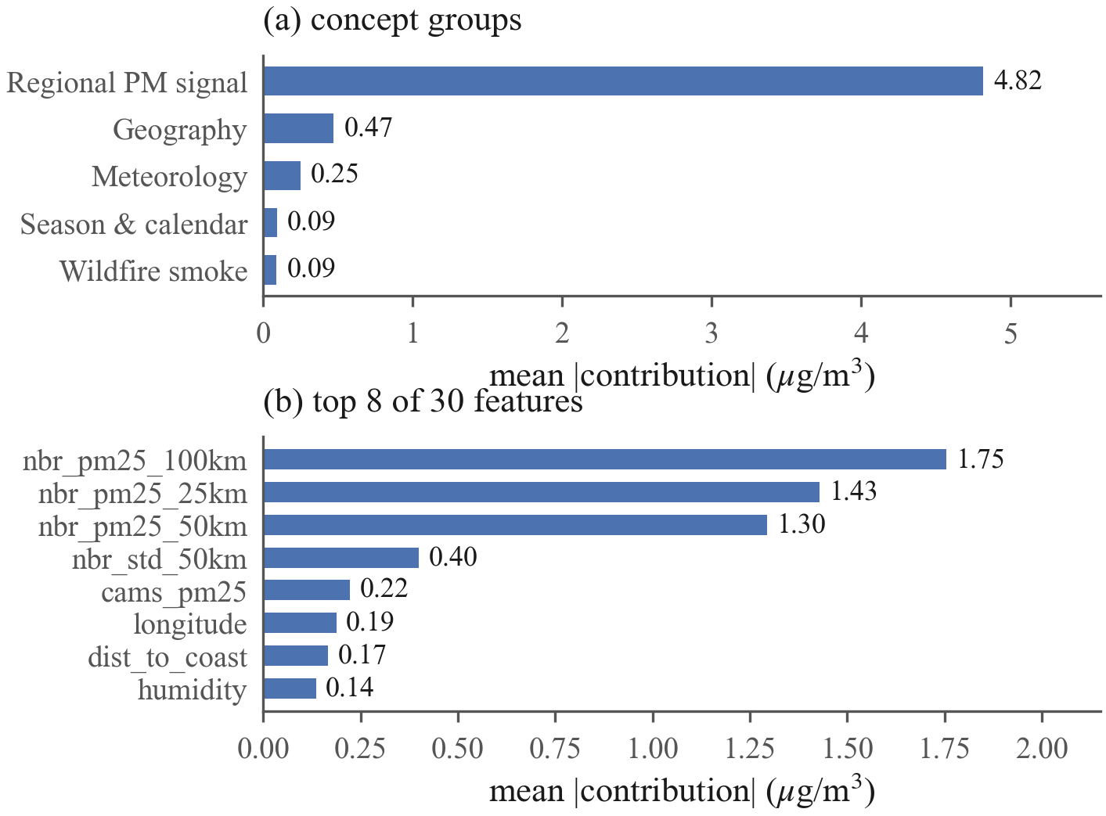
Fig. 1. Global importance over the 6,000-row sample. (a) Mean absolute concept-group contribution; the regional PM signal exceeds every other group by an order of magnitude. (b) The top individual features are the three neighbor means, neighbor dispersion, and CAMS surface PM2.5.
IV. Results
A. The model is a spatial nowcaster
Fig. 1 shows global importance. The regional PM signal group averages 4.82 μg/m³ of absolute contribution per prediction (95% CI [4.71,4.93]); the next group, geography, averages 0.47 μg/m³ [0.41,0.53], an order of magnitude smaller, followed by meteorology at 0.25 μg/m³, season and calendar at 0.091 μg/m³, and the dedicated smoke tier last at 0.090 μg/m³. The three neighbor-mean features are individually the three most important inputs (1.75, 1.43, and 1.30 μg/m³ at 100, 25, and 50 km). Whatever else the ensemble encodes, its predictions are first and foremost a spatial average of what nearby sensors already report.
The top of that ordering is not in doubt: the regional group's interval is disjoint from every other, and grouped permutation importance reproduces the ranking exactly (rank correlation 1.0). The full five-way ranking survives 65.8% of 1,000 sensor-clustered resamples, the instability confined to the bottom pair: season (0.091) and smoke (0.090) differ by 0.001 μg/m³ with near-coincident intervals, so their order flips at random.

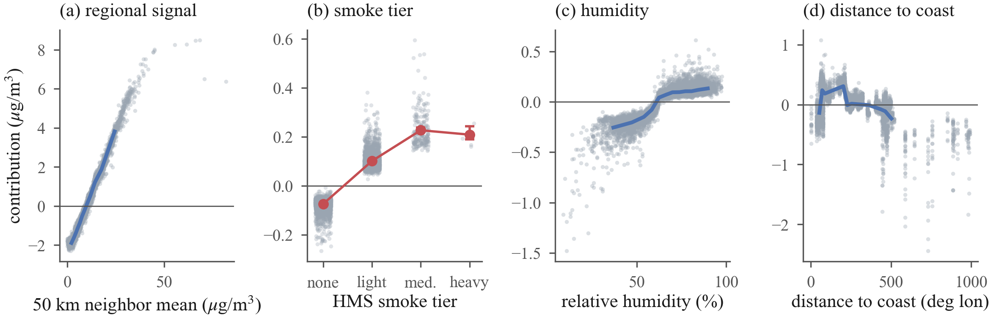
Fig. 2. Feature dependence on the 6,000-row sample (gray points; blue line is the 12-quantile binned median). (a) Contribution of the 50 km neighbor mean is near-linear then flattens above 40 μg/m³. (b) HMS smoke tier: red markers are exact means over all 431 heavy-tier rows and 2,500 medium-tier rows with day-clustered bootstrap 95% intervals; the heavy tier shows no increase over medium. (c) Humidity contributes weakly but monotonically, with a threshold near 60% RH. (d) Distance to coast trends negative inland, encoding the Gulf moisture gradient and sensor-network density rather than a causal effect of position.

B. Feature response and semantics
Dependence analysis (Fig. 2) sharpens this picture in three ways.
1) Near-linear regional response: The 50 km neighbor mean maps onto its attribution almost monotonically (Spearman ρ=0.993), with slope 0.25 μg/m³ per 1 μg/m³ of neighbor mean below 30 μg/m³, then flattens: over corpus rows, the median contribution is +5.78 μg/m³ for neighbor means between 30 and 40 μg/m³ (2,000 of 4,060 rows sampled) and +7.39 μg/m³ (CI [7.37, 7.43], all 860 qualifying rows) above 40 μg/m³. The flattening is consistent with the exclusion of training days above 75 μg/m³: the model has little headroom to extrapolate events it never saw.
2) The smoke tier is nearly redundant: Mean attribution of the HMS tier, in μg/m³, is -0.074 (none) and +0.101 (light) on the sample, +0.227 over 2,500 recomputed medium-tier rows (day-clustered CI [0.218, 0.238]), and +0.209 over all 431 heavy-tier rows (CI [0.191, 0.243]; the heavy rows fall on only 31 days). Heavy-tier attribution shows no increase over medium (difference CI [-0.018, 0.041] μg/m³), and the whole tier range is negligible against a LOSO RMSE near 4.2 μg/m³. Only 431 of 285,798 training rows (0.15%) carry the heavy tier, and on those rows mean observed PM2.5 is lower than on medium-tier rows (11.6 versus 16.6 μg/m³), a reminder that an analyst-drawn plume overhead does not guarantee surface-level smoke. The model nearly ignores a feature whose evidential value its training data did not support.
3) The disparity survives the exclusion: Correlating tract predictions (6,896 tracts, 365 days) afterwards against EJScreen percentiles the model never sees, low income rises monotonically across quintiles from 8.58 to 9.29 μg/m³ (ρ=0.16); percent people of color is non-monotone, dipping to 8.67 mid-range before reaching 9.38. The disparity is real but uneven, and, with no demographic input, inferred from atmospheric evidence alone.
4) Interactions stay inside the regional group: SHAP interaction values (a 400-row subsample, seed 42; random forest and CatBoost blended with renormalized weights covering 93% of the deployed ensemble, LightGBM omitted as its interaction runtime exceeded budget) rank the six leading pairs entirely within the regional signal group: the three neighbor means interact at 0.48, 0.41, and 0.30 μg/m³ mean absolute strength, followed by three neighbor-dispersion pairs. The strongest cross-group pair, humidity with the 100 km neighbor mean, is weaker at 0.06 μg/m³. Regional dominance is not an artifact of additive attribution. Magnitudes are taken after the signed blend, so model disagreement cannot inflate a pair.
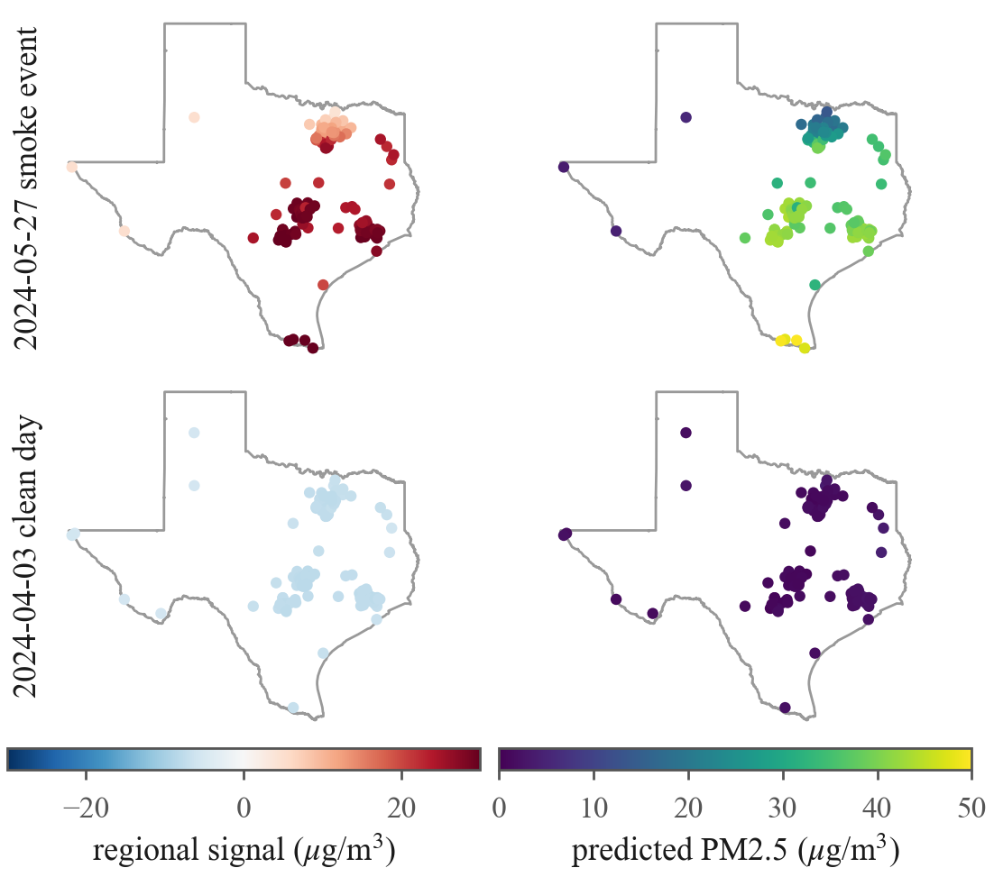
Fig. 3. Every reporting sensor explained on the strongest smoke day (top, 156 sensors, 98.7% under a plume) and the cleanest day (bottom, 154 sensors): regional-signal contribution (left) and predicted PM2.5 (right). The event is carried almost entirely by the regional signal (+24.3 μg/m³ statewide mean) while the smoke tier peaks at +0.64 μg/m³ anywhere in the state.
C. Two days, one mechanism
On May 27, 2024 (Fig. 3), with 98.7% of sensors under an analyst-drawn plume and a statewide mean reading of 37.0 μg/m³, the model predicted a mean of 36.0 μg/m³, and the regional signal group contributed +24.3 μg/m³ of that on average. The smoke tier's mean contribution that day was +0.4 μg/m³. On April 3, 2024 (statewide mean 1.03 μg/m³), the regional group pulled predictions down by 7.6 μg/m³ on average from the 9.65 μg/m³ baseline. Smoke information reaches the model through the neighbor network, not the smoke feature: both days are settings of one nowcasting mechanism.
D. Explaining a success and a failure
Fig. 4 decomposes two individual predictions. On the smoke day, sensor 217461 read 71.1 μg/m³ and the model predicted 49.8 μg/m³, with +34.6 μg/m³ from the regional signal and +0.64 μg/m³ from the smoke tier; even this detection underpredicts, consistent with the capped training range and the saturating neighbor response. On November 19, 2024, sensor 242357 read 75.0 μg/m³, at the retention boundary itself, while every neighbor mean sat below 1.8 μg/m³; the model predicted 5.1 μg/m³. The explanation shows why: the regional group contributed -5.9 μg/m³, with the 100 km neighbor mean alone at -2.2 μg/m³. Nor is the case unique: 46 corpus rows read at least 40 μg/m³ with every neighbor mean below 5 μg/m³; the regional group is negative on all 46 (mean -4.9 μg/m³), and the highest prediction among them is 8.5 μg/m³ against a mean observation of 54.1 μg/m³. Rows above 75 μg/m³ were excluded (241 pre-cap), so these figures lower-bound the blind spot. The features that make the model accurate on regional events actively vote against hyper-local ones; no reweighting of the same features can fix what the network cannot see.
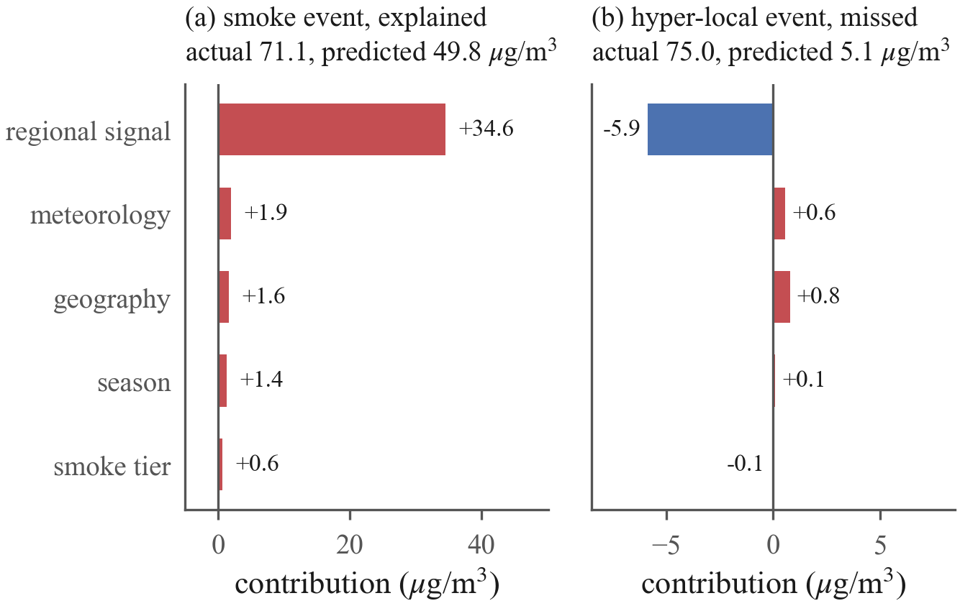
Fig. 4. Exact concept-group decomposition of two predictions. (a) A detected smoke event is carried by the regional signal; the smoke tier adds +0.6 μg/m³. (b) The worst miss in the corpus: neighbors saw nothing, and the regional signal suppresses the prediction below the baseline.
V. Discussion

A. For model builders
The smoke tier could be replaced rather than retuned: plume density, smoke age, or lagged fire radiative power. The saturating neighbor response ties directly to the 75 μg/m³ training cap, so raising it is a measurable next experiment.
B. For network operators
The miss case turns an error metric into a map, with one caution: sign alone cannot separate clean surroundings from unsensed ones (the clean day's statewide mean regional contribution, -7.6 μg/m³, is as negative as El Paso's annual -6.8 μg/m³). Sparsity separates them: the El Paso sensor averages 0.8 same-day neighbors within 50 km against a statewide 27, and its regional contribution averages -6.8 μg/m³ against East Texas's +1.34 μg/m³ (up to +9.4). Persistently negative regional means in sparse neighborhoods mark where predictions rest on remote evidence (distance to the nearest sensor reaches 164 km), and those are the places where the platform's placement optimizer should spend new sensors; the explanation layer supplies that prioritization for free.
C. For communicating attributions
SHAP explains the model, not the atmosphere. Distance to coast and longitude are the clearest example: both carry real signal, but they encode where the sensor network and the Gulf moisture gradient sit, not a causal effect of coordinates on particulate matter. Public-facing deployment of these explanations needs the concept-group framing and an explicit correlational disclaimer as defaults, not footnotes. Carrying no demographic input (Section II) removes the sharpest misreading risk, but does not make the remaining attributions causal.
D. Limitations
The target is the uncorrected ATM channel, so absolute levels are not comparable to regulatory monitors without a correction such as that of Barkjohn et al. [1]; the explanations inherit whatever bias that channel carries. Days above 75 μg/m³ are absent from training, so extreme-event behavior describes a model that never saw the worst days, and the failure analysis lower-bounds the blind spot. LOSO R² characterizes held-out sensor locations; accuracy at unsensed tracts is unquantified, and the miss case suggests it degrades exactly there. Every attribution is conditioned on a network whose placement is itself demographically uneven [2]: the regional-signal group is powerful precisely where sensors are dense, so these explanations describe an unevenly observed state, not Texas uniformly. Tree-path-dependent attribution spreads credit among correlated features, so within-group rankings are less certain than group totals. Explanation statistics describe the training frame, not the serving distribution. The findings describe one model over one state and five years; the method applies unchanged to any convex blend of tree models.
VI. Conclusion
We converted a deployed, accuracy-validated PM2.5 mapping system into one whose every prediction can be read: an exact blend of per-model TreeExplainer attributions, folded into five concept groups, reconstructs each output to machine precision. The reading is unflattering in places. The model is a spatial nowcaster that nearly ignores its smoke tier, leans on geography as a proxy for network density, and structurally cannot see events its sensor network does not cover. None of this is visible in R², and all of it matters for how the tool should be used, improved, and communicated. Explaining 6,000 predictions takes under six minutes on a desktop CPU and one prediction a fraction of a second, so attaching exact, plainly narrated explanations to the live platform is the immediate next step.
References
[1] K. K. Barkjohn, B. Gantt, and A. L. Clements, “Development and application of a United States-wide correction for PM_{2.5} data collected with the PurpleAir sensor,” Atmospheric Measurement Techniques, vol. 14, no. 6, pp. 4617–4637, 2021.
[2] P. deSouza and P. L. Kinney, “On the distribution of low-cost PM2.5 sensors in the US: demographic and air quality associations,” Journal of Exposure Science & Environmental Epidemiology, vol. 31, no. 3, pp. 514–524, 2021.
[3] S. M. Lundberg and S.-I. Lee, “A unified approach to interpreting model predictions,” in Advances in Neural Information Processing Systems 30, 2017, pp. 4765–4774.
[4] S. M. Lundberg et al., “From local explanations to global understanding with explainable AI for trees,” Nature Machine Intelligence, vol. 2, no. 1, pp. 56–67, 2020.
[5] B. Choubin, A. Jaafari, J. Henareh, O. Karimi, and F. Sajedi Hosseini, “Explainable artificial intelligence (XAI) for interpreting predictive models and key variables in flood susceptibility,” Results in Engineering, vol. 27, p. 105976, 2025.
[6] U.S. Environmental Protection Agency, “Reconsideration of the National Ambient Air Quality Standards for Particulate Matter; final rule,” Federal Register, vol. 89, p. 16202, Mar. 6, 2024, effective May 6, 2024.
[7] P. Zippenfenig, “Open-Meteo.com weather API,” Zenodo, 2023, computer software.
[8] S. J. Brey, M. Ruminski, S. A. Atwood, and E. V. Fischer, “Connecting smoke plumes to sources using Hazard Mapping System (HMS) smoke and fire location data over North America,” Atmospheric Chemistry and Physics, vol. 18, no. 3, pp. 1745–1761, 2018.
[9] V.-H. Peuch et al., “The Copernicus Atmosphere Monitoring Service: From research to operations,” Bulletin of the American Meteorological Society, vol. 103, no. 12, pp. E2650–E2668, 2022.
[10] U.S. Environmental Protection Agency, “EJScreen technical documentation for version 2.3,” U.S. EPA Office of Environmental Justice and External Civil Rights, Washington, DC, Tech. Rep., Jul. 2024, archived EPA snapshot of Jan. 19, 2025. [Online]. Available: https://19january2025snapshot.epa.gov/system/files/documents/2024-07/ejscreen-tech-doc-version-2-3.pdf
[11] L. Breiman, “Random forests,” Machine Learning, vol. 45, no. 1, pp. 5–32, Oct. 2001.
[12] G. Ke et al., “LightGBM: A highly efficient gradient boosting decision tree,” in Advances in Neural Information Processing Systems 30, 2017, pp. 3146–3154.
[13] T. Chen and C. Guestrin, “XGBoost: A scalable tree boosting system,” in Proceedings of the 22nd ACM SIGKDD International Conference on Knowledge Discovery and Data Mining. ACM, 2016, pp. 785–794.
[14] L. Prokhorenkova, G. Gusev, A. Vorobev, A. V. Dorogush, and A. Gulin, “CatBoost: unbiased boosting with categorical features,” in Advances in Neural Information Processing Systems 31 (NeurIPS 2018), 2018, pp. 6639–6649.
[15] H. Meyer and E. Pebesma, “Machine learning-based global maps of ecological variables and the challenge of assessing them,” Nature Communications, vol. 13, no. 1, p. 2208, 2022.
[16] M. Jullum, A. Redelmeier, and K. Aas, “groupShapley: Efficient prediction explanation with Shapley values for feature groups,” arXiv:2106.12228, 2021.

